***Application Development***

***Coursework 1***

**Title:** Windows form application using C# - E-Pupil SMS

**Student Name:** R. Anushka Diwolka Wijegoonawardana.

**Registration Number:** E116517

**Date Submitted:** 2021 April 18th

TABEL OF CONTENTS

TABEL OF CONTENTS 2

INTRODUCTION 3

HOW TO USE THE PROGRAMME 3

SOFTWARE ARCHITECTURE 3

TECHNICAL DESCRIPTION 3

REFECLTION & EXPERIENCE 4

REFERENCE / BIBLIOGRAPHY **Error! Bookmark not defined.**

INTRODUCTION

As a software engineering undergraduate student, I was given to develop software using C# windows form. This software is for an OMP International School. This system is called an e-pupil. OMP school can keep student details, class details, staff details, track student marks generate various reports are a few of the things that can do using this system.

HOW TO USE THE PROGRAMME

SOFTWARE ARCHITECTURE

The organization of a software program how its component is developed, how the component is connected & how they communicate between components can be explained as the Software Architecture.

When we are developing a window form application using the C# programming language, we have several architectural options but the most common one is a client-server architecture.

In this, the desktop application database will be worked as the server & the interfaces will be worked as the client. Even though the database will be stored on the same device these two worked separately.

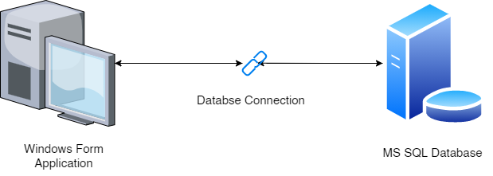

Figure 1: Client Server Architecture

TECHNICAL DESCRIPTION

Technologies & Softwares Used

* C# Programing Language
* Microsoft Visual Studio Code
* XD
* Microsoft SQL Server Management Studio

Designing of The Application

Have use the XD to create the skeleton of the application design. UI are design according to the google material UI design framework.

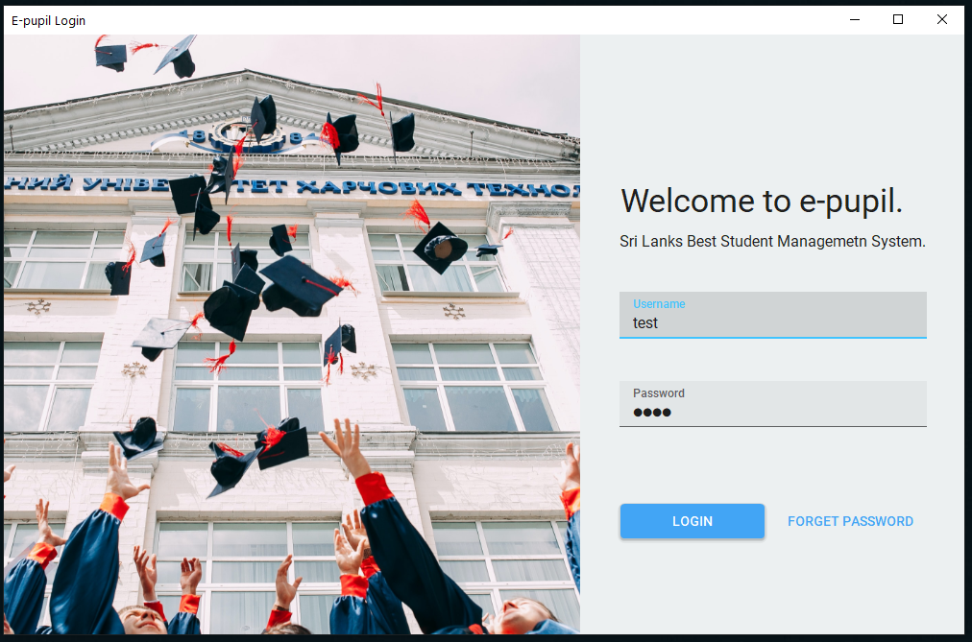

Figure 2: Login UI

Classes Methods & Properties

REFECLTION & EXPERIENCE

SOFTWARE FILE

<https://github.com/AnushkaWijegoonawardana97/LMU-Applocation-Development-CW1>